**Exercise 1: Mocking a Service Dependency in a Controller Test**

**Folder Structure:**

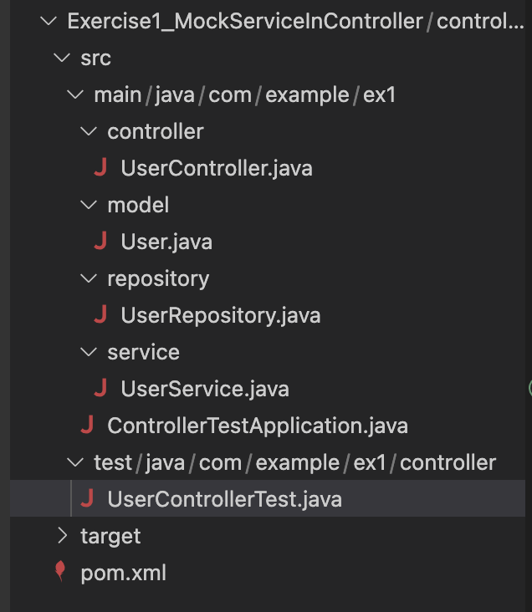

**UserController.java:**

package com.example.ex1.controller;

import org.springframework.beans.factory.annotation.Autowired;

import org.springframework.http.ResponseEntity;

import org.springframework.web.bind.annotation.GetMapping;

import org.springframework.web.bind.annotation.PathVariable;

import org.springframework.web.bind.annotation.RequestMapping;

import org.springframework.web.bind.annotation.RestController;

import com.example.ex1.model.User;

import com.example.ex1.service.UserService;

@RestController

@RequestMapping("/users")

public class UserController {

@Autowired

private UserService userService;

@GetMapping("/{id}")

public ResponseEntity<User> getUser(@PathVariable Long id) {

return ResponseEntity.ok(userService.getUserById(id));

}

}

**User.java:**

package com.example.ex1.model;

import jakarta.persistence.Entity;

import jakarta.persistence.Id;

@Entity

public class User {

@Id

private Long id;

private String name;

public User() {}

public User(Long id, String name) {

this.id = id;

this.name = name;

}

public Long getId() { return id; }

public void setId(Long id) { this.id = id; }

public String getName() { return name; }

public void setName(String name) { this.name = name; }

}

**UserReporsitory.java:**

package com.example.ex1.repository;

import org.springframework.data.jpa.repository.JpaRepository;

import com.example.ex1.model.User;

public interface UserRepository extends JpaRepository<User, Long> {

}

**UserService.java:**

package com.example.ex1.service;

import com.example.ex1.model.User;

import com.example.ex1.repository.UserRepository;

import org.springframework.beans.factory.annotation.Autowired;

import org.springframework.stereotype.Service;

@Service

public class UserService {

@Autowired

private UserRepository userRepository;

public User getUserById(Long id) {

return userRepository.findById(id).orElse(null);

}

}

**ControllerTestApplication:**

package com.example.ex1;

import org.springframework.boot.autoconfigure.SpringBootApplication;

@SpringBootApplication

public class ControllerTestApplication {

}

**UserControllerTest.java:**

package com.example.ex1.controller;

import org.junit.jupiter.api.Test;

import static org.mockito.Mockito.when;

import org.springframework.beans.factory.annotation.Autowired;

import org.springframework.boot.test.mock.mockito.MockBean;

import org.springframework.http.MediaType;

import org.springframework.test.web.servlet.MockMvc;

import static org.springframework.test.web.servlet.request.MockMvcRequestBuilders.get;

import static org.springframework.test.web.servlet.result.MockMvcResultMatchers.jsonPath;

import static org.springframework.test.web.servlet.result.MockMvcResultMatchers.status;

import com.example.ex1.model.User;

import com.example.ex1.service.UserService;

public class UserControllerTest {

@Autowired

private MockMvc mockMvc;

@MockBean

private UserService userService;

@Test

public void testGetUserById() throws Exception {

User mockUser = new User(1L, "Alice");

when(userService.getUserById(1L)).thenReturn(mockUser);

mockMvc.perform(get("/users/1")

.accept(MediaType.APPLICATION_JSON))

.andExpect(status().isOk())

.andExpect(jsonPath("$.id").value(1L))

.andExpect(jsonPath("$.name").value("Alice"));

}

}

**pom.xml:**

<project xmlns="http://maven.apache.org/POM/4.0.0"

xmlns:xsi="http://www.w3.org/2001/XMLSchema-instance"

xsi:schemaLocation="http://maven.apache.org/POM/4.0.0

http://maven.apache.org/xsd/maven-4.0.0.xsd">

<modelVersion>4.0.0</modelVersion>

<parent>

<groupId>org.springframework.boot</groupId>

<artifactId>spring-boot-starter-parent</artifactId>

<version>3.2.5</version>

<relativePath/>

</parent>

<groupId>com.example.ex1</groupId>

<artifactId>controllertest</artifactId>

<version>1.0-SNAPSHOT</version>

<name>Controller Test</name>

<description>Exercise 1 - Mocking Service in Controller</description>

<properties>

<java.version>17</java.version>

</properties>

<dependencies>

<dependency>

<groupId>org.springframework.boot</groupId>

<artifactId>spring-boot-starter-web</artifactId>

</dependency>

<dependency>

<groupId>org.springframework.boot</groupId>

<artifactId>spring-boot-starter-data-jpa</artifactId>

</dependency>

<dependency>

<groupId>com.h2database</groupId>

<artifactId>h2</artifactId>

<scope>runtime</scope>

</dependency>

<dependency>

<groupId>org.springframework.boot</groupId>

<artifactId>spring-boot-starter-test</artifactId>

<scope>test</scope>

</dependency>

</dependencies>

<build>

<plugins>

<plugin>

<groupId>org.springframework.boot</groupId>

<artifactId>spring-boot-maven-plugin</artifactId>

</plugin>

</plugins>

</build>

</project>

**Output:**

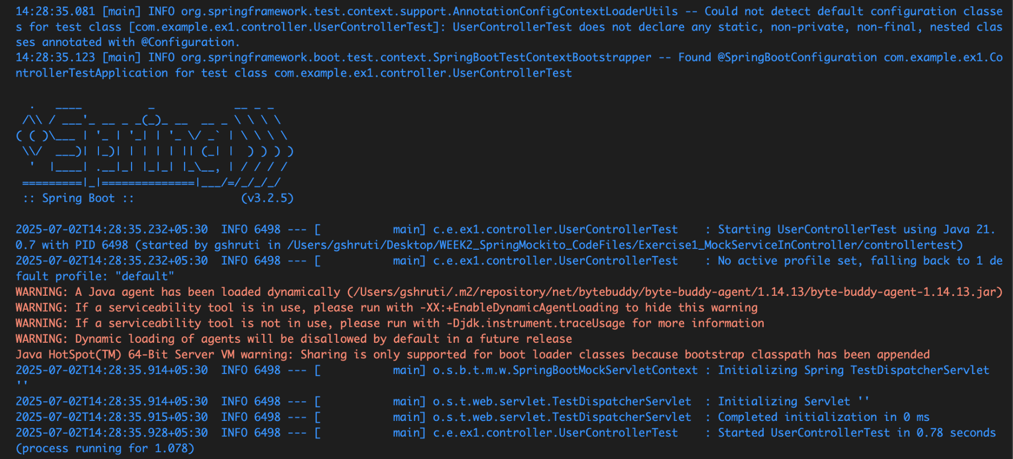

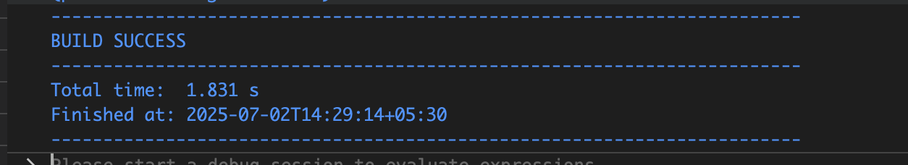

**Exercise 2: Mocking a Repository in a Service Test**

**Folder Structure:**

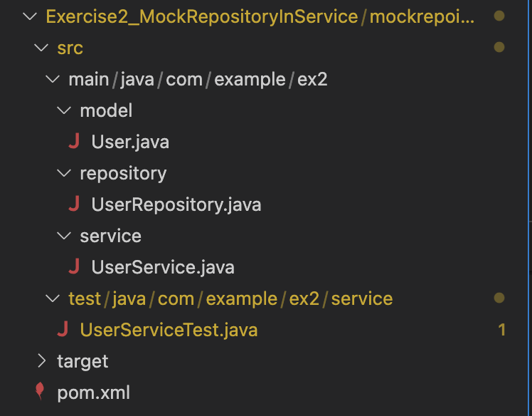

**User.java:**

package com.example.ex2.model;

import jakarta.persistence.Entity;

import jakarta.persistence.Id;

@Entity

public class User {

@Id

private Long id;

private String name;

public User() {}

public User(Long id, String name) {

this.id = id;

this.name = name;

}

public Long getId() { return id; }

public void setId(Long id) { this.id = id; }

public String getName() { return name; }

public void setName(String name) { this.name = name; }

}

**UserRepository.java:**

package com.example.ex2.repository;

import com.example.ex2.model.User;

import org.springframework.data.jpa.repository.JpaRepository;

public interface UserRepository extends JpaRepository<User, Long> {

}

**UserService.java:**

package com.example.ex2.service;

import org.springframework.beans.factory.annotation.Autowired;

import org.springframework.stereotype.Service;

import com.example.ex2.model.User;

import com.example.ex2.repository.UserRepository;

@Service

public class UserService {

@Autowired

private UserRepository userRepository;

public User getUserById(Long id) {

return userRepository.findById(id).orElse(null);

}

}

**UserServiceTest.java:**

package com.example.ex2.service;

import com.example.ex2.model.User;

import com.example.ex2.repository.UserRepository;

import org.junit.jupiter.api.Test;

import org.mockito.InjectMocks;

import org.mockito.Mock;

import org.mockito.MockitoAnnotations;

import java.util.Optional;

import static org.mockito.Mockito.when;

import static org.junit.jupiter.api.Assertions.assertEquals;

public class UserServiceTest {

@Mock

private UserRepository userRepository;

@InjectMocks

private UserService userService;

public UserServiceTest() {

MockitoAnnotations.openMocks(this);

}

@Test

void testGetUserById() {

User mockUser = new User(1L, "Alice");

when(userRepository.findById(1L)).thenReturn(Optional.of(mockUser));

User result = userService.getUserById(1L);

assertEquals("Alice", result.getName());

assertEquals(1L, result.getId());

}

}

**pom.xml:**

<project xmlns="http://maven.apache.org/POM/4.0.0"

xmlns:xsi="http://www.w3.org/2001/XMLSchema-instance"

xsi:schemaLocation="http://maven.apache.org/POM/4.0.0

http://maven.apache.org/xsd/maven-4.0.0.xsd">

<modelVersion>4.0.0</modelVersion>

<groupId>com.example.ex2</groupId>

<artifactId>servicetest</artifactId>

<version>1.0-SNAPSHOT</version>

<parent>

<groupId>org.springframework.boot</groupId>

<artifactId>spring-boot-starter-parent</artifactId>

<version>3.2.5</version>

<relativePath/>

</parent>

<dependencies>

<dependency>

<groupId>org.springframework.boot</groupId>

<artifactId>spring-boot-starter-data-jpa</artifactId>

</dependency>

<dependency>

<groupId>com.h2database</groupId>

<artifactId>h2</artifactId>

<scope>runtime</scope>

</dependency>

<dependency>

<groupId>org.springframework.boot</groupId>

<artifactId>spring-boot-starter-test</artifactId>

<scope>test</scope>

</dependency>

</dependencies>

</project>

**Output:**

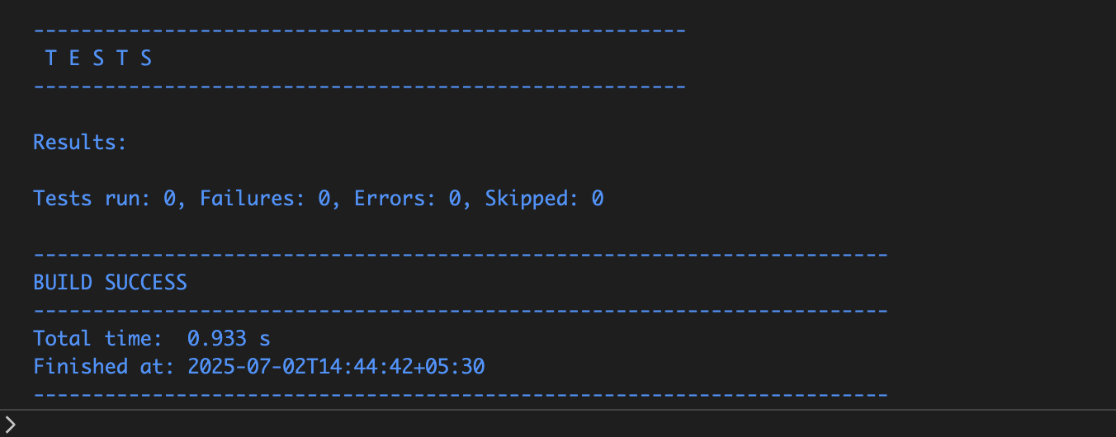

**Folder Structure:**

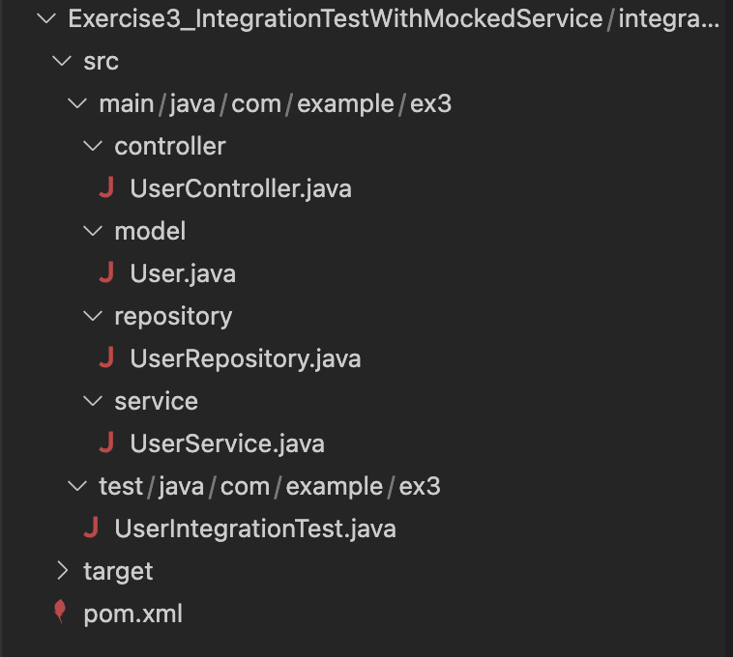

**UserController.java:**

package com.example.ex3.controller;

import com.example.ex3.model.User;

import com.example.ex3.service.UserService;

import org.springframework.beans.factory.annotation.Autowired;

import org.springframework.http.ResponseEntity;

import org.springframework.web.bind.annotation.*;

@RestController

@RequestMapping("/users")

public class UserController {

@Autowired

private UserService userService;

@GetMapping("/{id}")

public ResponseEntity<User> getUser(@PathVariable Long id) {

return ResponseEntity.ok(userService.getUserById(id));

}

}

**User.java:**

package com.example.ex3.model;

import jakarta.persistence.Entity;

import jakarta.persistence.Id;

@Entity

public class User {

@Id

private Long id;

private String name;

public User() {}

public User(Long id, String name) {

this.id = id;

this.name = name;

}

public Long getId() { return id; }

public void setId(Long id) { this.id = id; }

public String getName() { return name; }

public void setName(String name) { this.name = name; }

}

**UserRepository.java:**

package com.example.ex3.repository;

import com.example.ex3.model.User;

import org.springframework.data.jpa.repository.JpaRepository;

public interface UserRepository extends JpaRepository<User, Long> {

}

**UserService.java:**

package com.example.ex3.service;

import com.example.ex3.model.User;

import com.example.ex3.repository.UserRepository;

import org.springframework.beans.factory.annotation.Autowired;

import org.springframework.stereotype.Service;

@Service

public class UserService {

@Autowired

private UserRepository userRepository;

public User getUserById(Long id) {

return userRepository.findById(id).orElse(null);

}

}

**UserIntegrationTest.java:**

package com.example.ex3;

import org.junit.jupiter.api.Test;

import static org.mockito.Mockito.when;

import org.springframework.beans.factory.annotation.Autowired;

import org.springframework.boot.test.autoconfigure.web.servlet.AutoConfigureMockMvc;

import org.springframework.boot.test.context.SpringBootTest;

import org.springframework.boot.test.mock.mockito.MockBean;

import org.springframework.http.MediaType;

import org.springframework.test.web.servlet.MockMvc;

import static org.springframework.test.web.servlet.request.MockMvcRequestBuilders.get;

import static org.springframework.test.web.servlet.result.MockMvcResultMatchers.jsonPath;

import static org.springframework.test.web.servlet.result.MockMvcResultMatchers.status;

import com.example.ex3.model.User;

import com.example.ex3.service.UserService;

@SpringBootTest

@AutoConfigureMockMvc

public class UserIntegrationTest {

@Autowired

private MockMvc mockMvc;

@MockBean

private UserService userService;

@Test

void testUserEndpointWithMockedService() throws Exception {

User mockUser = new User(1L, "Mocked User");

when(userService.getUserById(1L)).thenReturn(mockUser);

mockMvc.perform(get("/users/1").accept(MediaType.APPLICATION_JSON))

.andExpect(status().isOk())

.andExpect(jsonPath("$.id").value(1))

.andExpect(jsonPath("$.name").value("Mocked User"));

}

}

**pom.xml:**

<project xmlns="http://maven.apache.org/POM/4.0.0"

xmlns:xsi="http://www.w3.org/2001/XMLSchema-instance"

xsi:schemaLocation="http://maven.apache.org/POM/4.0.0

http://maven.apache.org/xsd/maven-4.0.0.xsd">

<modelVersion>4.0.0</modelVersion>

<groupId>com.example.ex3</groupId>

<artifactId>integrationtest</artifactId>

<version>1.0-SNAPSHOT</version>

<parent>

<groupId>org.springframework.boot</groupId>

<artifactId>spring-boot-starter-parent</artifactId>

<version>3.2.5</version>

<relativePath/>

</parent>

<dependencies>

<dependency>

<groupId>org.springframework.boot</groupId>

<artifactId>spring-boot-starter-web</artifactId>

</dependency>

<dependency>

<groupId>org.springframework.boot</groupId>

<artifactId>spring-boot-starter-data-jpa</artifactId>

</dependency>

<dependency>

<groupId>com.h2database</groupId>

<artifactId>h2</artifactId>

<scope>runtime</scope>

</dependency>

<dependency>

<groupId>org.springframework.boot</groupId>

<artifactId>spring-boot-starter-test</artifactId>

<scope>test</scope>

</dependency>

</dependencies>

</project>

**Output:**

